Susana Martinez
Governor

Demesia Padilla, CPA
Cabinet Secretary

October 16, 2014
Name
Address
City, NM 87504

Certificate #

Resident Preference Certification Renewal

CONTRACTOR CERTIFICATION

Our records indicate that your Resident Preference Certification will expire in 30 days.

If you would like to renew your certificate for another three years, please mail your renewal request and the $35 application fee within fifteen (15) days of receipt of this letter to the address below. The Department will process your renewal request within 30 days of receipt. If your information has changed, please update below. If you have any questions, please call Sharon Kain at 505-827-0949.

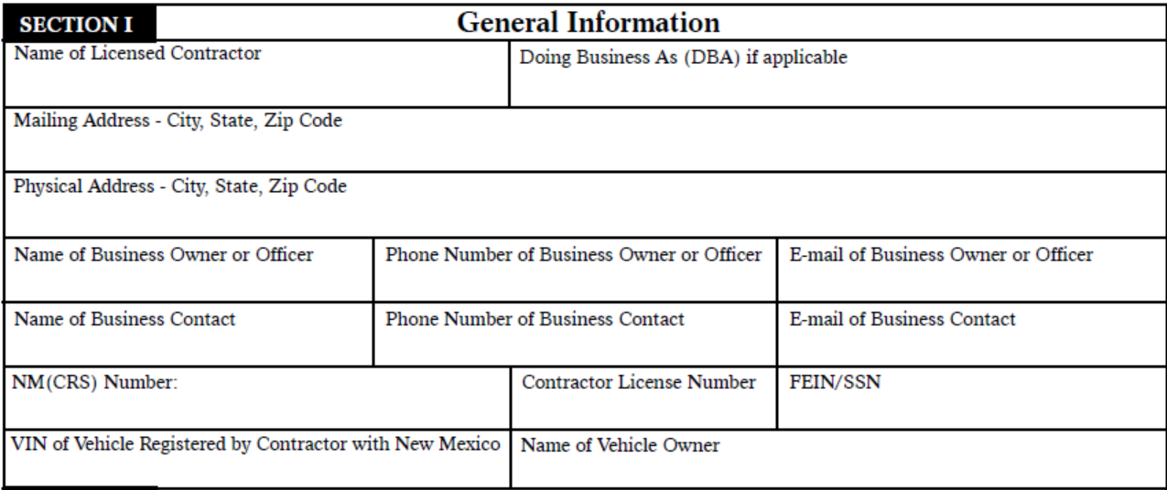
General Information

