Toolbox Talk
Monday, September 10th: National Suicide Prevention Week
Mental Health & Workplace Safety

For many years it was considered taboo to talk about mental health at work and other public places. Fortunately the stigma over talking about mental health is changing and SSC is working to be a leader in this.

It is important to treat mental health like we do physical health. We do not blame individuals for getting sick so we should be accepting of individuals who may be struggling with mental health issues. People affected by mental illness are not alone or uncommon – 1 in 5 adults deal with a mental health condition. People at risk for suicide are not weak and should not feel shame – they are in a place of hopelessness and we can show them that they are important and cared for!

Two mental health conditions that are most frequently observed in the workplace are depression and anxiety. Co-workers that are affected by these conditions may exhibit a lack of focus, slower reaction times and impaired decision making. Out of concern for their safety and the safety of your entire crew, connecting them with help if they are in need benefits not only the affected employee but the entire company.

Checking in with your crewmates to let them know you care demonstrates respect and concern for their wellbeing. Taking time to listen or being patient can go a long way to making people feel respected and cared for. SSC leadership supports employees taking the time to care for one another!

Mental health is a personal issue, a family issue, a community issue and a society issue. This is why attention to mental health is an important part of our SSC culture.

If someone is exhibiting any warning signs for suicide:
- Talking about wanting to die
- Talking about being a burden, feeling trapped or that it would be “better if they were gone”
- A change in behavior including being late, less productive, mood swings, more irritable, picking fights
- Acting anxious, agitated or reckless

Follow the #BeThe1To Steps:
- Ask – “Are you thinking about killing yourself?”
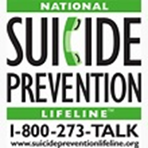
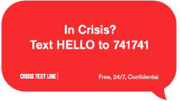
- Keep Them Safe –
    - Stay with them
    - Call the National Suicide Prevention Lifeline 1-800-273-7255
    - Text the Crisis Text Line “Hello” to 741741
    - Remove access to lethal means
- Be There – Let them know that you care and that you are there for them
- Help Them Connect – Find a counsellor, get treatment – SSC can help make these connections
- Follow Up – Check in, see how they are doing, be available to listen, give support

