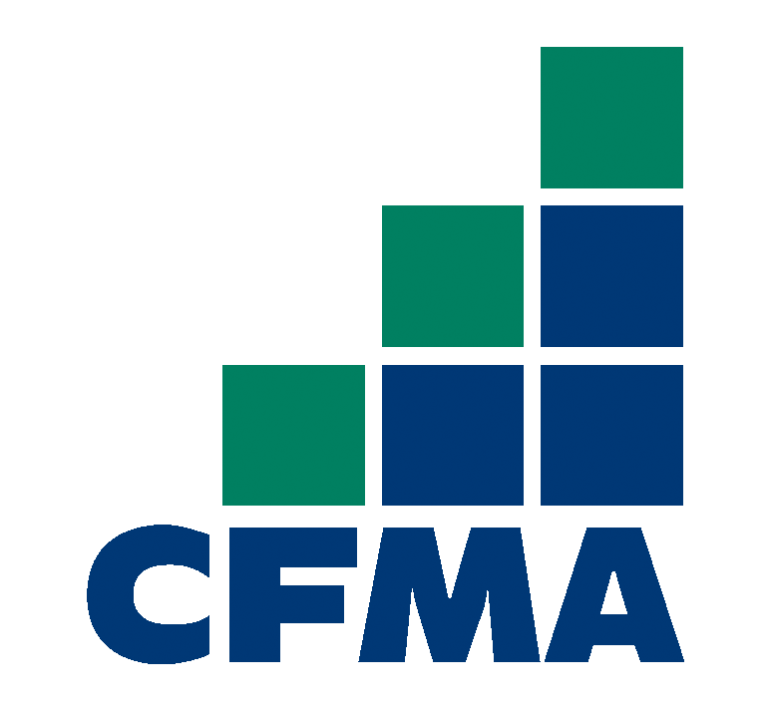
Thank you to our Platinum Sponsors

Thank you to our Gold Sponsors
AKT
CFO on the Go
Data Net Solutions
Pacific Building Group

