Risk Management & Safety Department
Toolbox Talk
Mental Health and Suicide Prevention Resources

There are two easy to use services that are free, confidential and available 24/7:

1. Crisis Text Line
This service is available for people of all ages who are looking for help. To contact Crisis Text Line all you do is text "hello" or "help" 741741. You will quickly receive a confirmation that your message is being routed to a counselor.
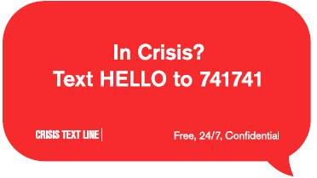
Crisis Text Line posters have been displayed in all major company facilities where employees gather. Crisis Text Line wallet cards have been distributed as well.

2. National Suicide Prevention Lifeline
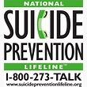
This service provides crisis intervention for people having thoughts about self-harm or who are considering taking their life. The telephone number is 800/273–8255.

Suicide prevention posters have been displayed in all company facilities and wallet cards have been distributed that highlight the warning signs for suicide risk. These both have the telephone number for the National Suicide Prevention Lifeline.

EMPLOYEE # PRINT NAME: SIGNATURE:

