It is my pleasure to share with you what is happening in your Puget Sound Chapter of CFMA.
On behalf of myself and Kevin Jacobs, we have considered it an honor to represent the Puget Sound CFMA Chapter as President and Treasurer for these past 3 years. It is said by John C. Maxwell that
“A leader is one who knows the way, goes the way, and shows the way.”
Both Kevin and I are pleased to mentor our replacements and wish them successful terms as the new Leaders of our Chapter.

The following are the 2018/2019 Puget Sound CFMA Board Members:
Officers:
President Grace Pizzey Holaday-Parks Vice President of Finance
Vice President Jim Weber Lakeside Industries Controller
Treasurer Brian Joyce Stoneway Concrete Controller
Secretary CJ Mitchell Columbia Bank VP, Relationship Manager

Directors:
Cheryl Nagel Sequoyah Electric Chief Financial Officer
Kevin Jacobs Moss Adams LLP Senior Manager
Ryan Anderson, CCIFP Lakeside Industries Controller
Stuart O’Farrell Gallagher Area Vice President, Surety
Rhett Ennis, CCIFP Berntson Porter & Co Senior Manager
Tim Nierman Parker Smith & Feek Principal, Construction Practice
Kyle Ducey WG Clark Construction Controller
Brian Guthrie Ashbaugh Beal Attorney
Christian Geismann Schuchart Construction Chief Financial Officer
To stay focused as a CFMA chapter and board, we strive to remind ourselves of our Purpose. We are proud of what we accomplish and want to remind our membership of our Vision and Mission as we continue to impact our industry in positive ways.

OUR VISION

Recognized Resource for Performance, Profitability & Professionalism in the Construction Industry

OUR MISSION

Provide Financial Professionals in the Construction Industry with Avenues for Education, Networking, Risk Management and Industry Involvement

Our Membership of the Puget Sound Chapter of CFMA is 31 years STRONG. We are among the largest chapters in the country, ranked #7 overall. The two largest Chapters in the U.S. are Valley of the Sun (Phoenix) and Chicago. Our Puget Sound Chapter has 136 current active members. Overall, CFMA National is now over 8,600 members! We value our membership’s commitment to our Puget Sound Chapter and ask everyone to spread the word about CFMA so that we may continue to grow and achieve our goals.

This past year, we held our very successful annual Puget Sound CFMA Golf Fundraiser and raised $15,400! A special thank you goes to the following Sponsors:
Propel Insurance, Title Sponsor

Major Sponsors
Moss Adams LLP Parker Smith & Feek
Gallagher Columbia Bank
Kibble & Prentice Approach Technology
Dexter + Chaney

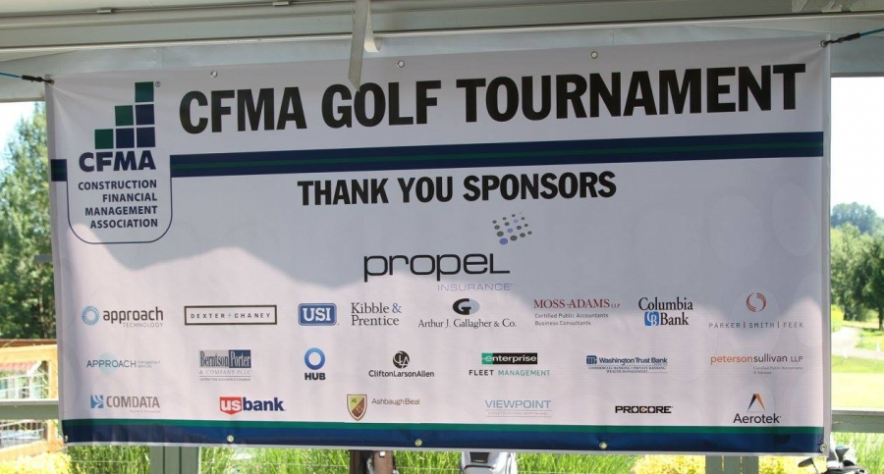

Our 2018 Golf Fundraiser will be held again at Willows Run Golf Course on June 21st. Registration is open, and Sponsors are still needed. Don’t forget to wear your College Colors and bring school spirit!
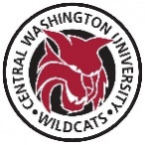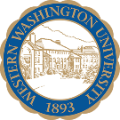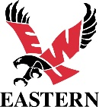

Click here to register and to sign up as a Sponsor
We use our Fundraiser to award Scholarships, provide Internships and give out Charitable Donations within our community.
The Puget Sound Chapter is fortunate to award a total of $10,000 in CFMA Scholarships for the September 2018 school year. Our focus is students pursuing degrees in Accounting, Finance and Construction Management in our community. Over the past several years, students from UW, WSU, Seattle U, Eastern, Gonzaga and CWU have been scholarship winners. It is truly our pleasure to announce the following winners:
Laura Goodnight UW – Accounting Major $6,000
Amanda Morales-Menchu WSU – Accounting Major $4,000

The process is enriching and many thanks to those in our membership who participated and served on the Scholarship Committee.
In addition to Scholarships, we are kicking off our Internship program. The goal is to support Puget Sound CFMA Member Companies to offer internships to students who want to work in the Construction Industry. We are excited to offer this new program to our members and look forward to making an impact for businesses in need of this resource. Keep an eye out for future information regarding this new Internship program.
This past year we also made Charitable Donations totaling $3,750 to the following organizations:
$2,500 Now Matters Now, a leader in the national Zero Suicide movement
$1,250 HomeAid Puget Sound, Building Homes, Rebuilding Lives
We consider it an honor to donate on behalf of the membership to charities that reach out and help others within our community.
Our Educational Meetings were fantastic this past year! All events are CPE accredited and an overview is listed as follows:
Sept 2017 SeaTac Airport Expansion
Presented by Port of Seattle Commissioner Stephanie Bowman
Oct 2017 Construction Industry Alliance for Suicide Prevention Summit
Moderated by Cal Beyer, Lakeside Industries, Director of Risk Management
Sponsored by Moss Adams LLP and Intl Union of Operating Engineers Local 302
Nov 2017 Spinach in Your Client’s Teeth and Other Etiquette Dilemmas
Presented by Arden Clise, President of Clise Etiquette
Jan 2018 Sound Transit – East Link Extension
Presented by
Mindy Levine-Archer, NBBJ Lead Architect of Master Plan for Spring District
Jason Hampton, Sound Transit Community Outreach Specialist
Feb 2018 GAAP and Tax Reform Update
Presented by
Kevin Jacobs, Senior Manager of Moss Adams LLP
Phil Knudson, Senior Tax Manager of Moss Adams LLP
Mar 2018 Workforce Development and Immigration Roundtable
Moderated by John Hurd, Lakeside Industries. Talent Acquisition Specialist Panelists were
Diane Kocer, AGC Education Foundation
Chance Gower, Career & Technical Education Director
for Highline Public Schools
Thomas Mosby, Executive Director of Career Pathways & Partnerships
for Highline Public Schools
Karen Dove, Executive Director for ANEW
April 2018 Shiny Object Syndrome – Developing a Cohesive Technology
Presented by Tim Goggin, CEO of Sappington
May 8, 2018 CFO Panel Discussion
Moderated by Stuart O’Farrell, Area VP, Surety, Gallagher
Sponsored by Berntson Porter & Company
Chief Financial Officer Panelists:
Cheryl Nagel, Sequoyah Electric, CFMA Past President
Dax Woolston, Lakeside Industries, CFMA Past President
Rich Finlay, BNBuilders
June 21, 2018 Puget Sound CFMA Annual Golf Tournament Fundraiser

We are looking forward to our May CFO Panel Discussion event and June Golf Fundraiser and hope everyone from our membership will register for both events.

None of these highlighted events happen without participation from our various Committees. It takes hours of planning and we encourage anyone to participate. If you are interested in volunteering and want to give back through CFMA and our chapter, please email us at PugetSound@cfma.org.

Finally, I personally want to congratulate my friend and construction industry peer Grace Pizzey, VP of Finance at Holaday-Parks, as our new Puget Sound CFMA Chapter President. With 25 years of financial and business management experience, I look forward to her Leadership and vision for our chapter.

Thank you all for being a member of the Puget Sound CFMA Chapter. Without you, we would not be impacting our Industry and Community. On behalf of myself and the entire Puget Sound CFMA Board of Directors, we look forward to another amazing year!

Cheryl Nagel
Puget Sound CFMA
Past Chapter President

OFFICERS:

Cheryl Nagel
President
Sequoyah Electric

Clayton Rodgers
Vice President
Aldrich+Associates

Kevin Jacobs
Treasurer
Moss Adams LLP

Jim Weber
Secretary
Lakeside Industries
BOARD MEMBERS:
Stuart O’Farrell
Arthur J. Gallagher & Co.

Ryan Anderson, CCIFP
Lakeside Industries

Tim Nierman
Parker, Smith & Feek Inc.

Kevin Meabon
Columbia Bank

Rhett Ennis, CCIFP
Berntson Porter & Co.

Kyle Ducey
W.G. Clark

Grace Pizzey
Holaday Parks, Inc

Brian Joyce
Stoneway Concrete

Rich Skalbania
Ashbaugh Beal

