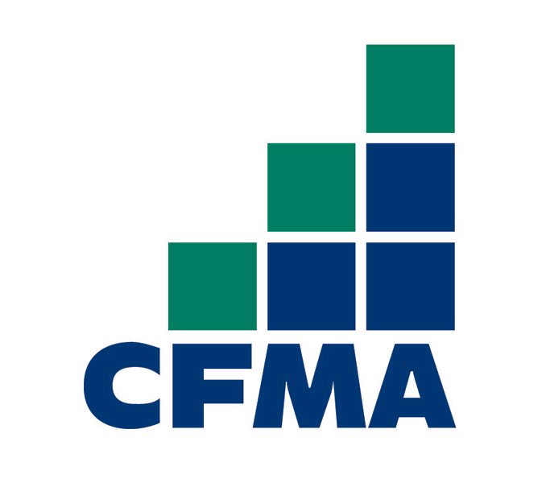

Maine Chapter

**Chapter Board Members, Officers and Committee Chairs (2015-2016)**

President

Tasha Gardner

BBSC CPAs

gardner@bbsccpa.com

Vice President

Rick Leonard

The Cianbro Companies

rleonard@cianbro.com

Secretary

Michelle Ibarguen

Cross Insurance

mibarguen@crossagency.com

Treasurer

Kevin Schroeher

NS Giles Foundations, Inc.

kevin.schroeher@nsgiles.com

Director

Phil Grondin

R.J. Grondin & Sons

pgrondin@grondinconstruction.com

Director

Sean Ferguson

CCB, Inc.

sferguson@ccb-inc.com

Director

Mary Johnson

Albin, Randall & Bennett, CPAs

mjohnson@arbcpa.com

Director

Holly Prellwitz

Wright-Ryan Construction, Inc.

hprellwitz@wright-ryan.com

Director

Michel Caouette

BerryDunn

MCaouette@berrydunn.com

Director

Tim Maynard

Maine Drilling & Blasting

tmaynard@mdandb.com

Director

David Sheldrick,

AmTrust Surety

David.sheldrick@amtrustgroup.com

Director

Alan Ray

E.S. Boulos Company

aray@esboulos.com

Membership Committee Chair

Patricia Peaslee

BBSC CPAs

peaslee@bbsccpa.com

Program Committee Chair

Kathryn Schneider

Dexter-Chaney

kschneider@dexterchaney.com

Scholarship Committee Chair

Cary Sheehan

Sargent Corporation

csheehan@sargent-corp.com

Communication Committee Chair

Mike Varney

Varney Agency

mvarney@varneyagency.com

Golf Committee Chair

Mike Blanchard

CCB, Inc.

mblanchard@ccb-inc.com

**Giving & Gathering**

**November Chapter Meeting**

**Tuesday, November 14, 2017**

***In the spirit of giving, we ask that attendees bring two canned goods to support the efforts of the Good Shepherd Food Bank of Maine***



**Hilton Garden Inn**

**Qualifies for 1.0 credit of CPE**

**Field of Study: Management Advisory Services**

no prerequisite or advanced preparation required

**250 Haskell Road**

**Bangor, ME**

5:00-6:00 Social Hour

6:00-7:00 Dinner

7:00-8:00 Program

**Turn Your Payables Department Into a Revenue Generator with Electronic Payment Solutions**

Construction Financial Managers, (CFM’s), need to find increased value from their accounting functions. Additionally, finding ways to improve yield on available cash can be challenging. Attend this session and learn how you can better optimize company payments to gain greater efficiency, improve controls, and turn your AP department into a money maker.

**Learning Objectives:**

* Simplify, Automate and Optimize Your Payment Processes
* Leverage Technology to Improve Your Disbursements Workflow
* Earn Rebates on Payments Using Corporate Payment Cards and ePayables
* Gain more control over employee expenses and fleet fuel management

**Our Speakers:**

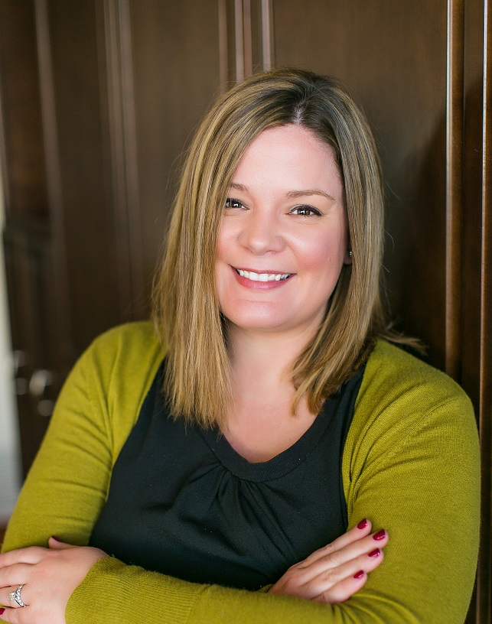

Nicole Frailey is Director of Strategic Sales for Comdata’s Construction Division, managing the Northeastern territory for Comdata’s largest construction customers. She has been with Comdata for over 10 years and has been an associate member of CFMA for 4 years.

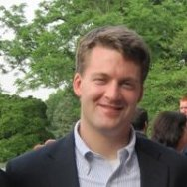Alex Kelley is Director of Strategic Sales for Comdata’s Corporate Payments Division, managing Maine, New Hampshire, and Massachusetts.  He’s has been in the payments industry for 8 years and is a member of CFMA/Massachusetts Chapter.

**Social hour sponsor:**



**RSVP: [Click here](http://maine.cfma.org/home)**to "Register Now" and complete payment via our online registration process.

**Cost:**

Members: $25.00

Guests: $50.00

**Remit checks made payable to “CFMA Maine Chapter” to:**

Doreen Bell, Tilson Technology Management

245 Commercial Street, Suite 203

Portland, ME 04101



Maine Chapter

**Chapter Board Members, Officers and Committee Chairs (2016-2017)**

President

Rick Leonard

The Cianbro Companies

RLeonard@cianbro.com

Vice President

Linda Roberts

Berry Dunn

LRoberts@berrydunn.com

Secretary

Phil Grondin

R. J. Grondin & Sons

pgrondin@grondinconstruction.com

Treasurer

Doreen Bell

Tilson Technology Management

DBell@tilsontech.com

Director and Past President

Tasha Gardner

Sargent Corporation

tgardner@sargent-corp.com

Director

Holly Prellwitz

Wright-Ryan

HPrellwitz@wright-ryan.com

Director

Tim Maynard

Maine Drilling & Blasting

tmaynard@mdandb.com

Director

Michelle Ibarguen

Cross Insurance

mibarguen@crossinsurance.com

Director

Kay Holbrook

Enterprise Engineering

klh@eeiteam.com

Membership Committee Chair

Julie Turner

R. J. Grondin & Sons

jturner@grondincontruction.com

Program Committee Chair

Kathryn Schneider

Dexter-Chaney

kschneider@dexterchaney.com

Scholarship Committee Chair

Shannon Walton

Clark Insurance

swalton@clarkinsurance.com

Communication Committee Chair

Melanie Bonnevie

Skillings Shaw & Associates

mbonnevie@ssasurety.com

Golf Committee Chair

Mike Varney

The Varney Agency

mvarney@varneyagency.com