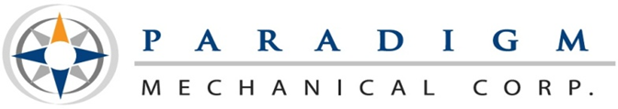
6550 Federal Blvd. ♦ Lemon Grove, CA 91945
(619) 456-4562 ♦ (619) 456-4754 fax ♦ www.pmccontracting.com
A Woman-Owned, Small Business
License # 947497

Construction Administrative Assistant
Paradigm Mechanical Corp. is currently looking for an experienced Construction Administrative Assistant to join our team. This is an excellent opportunity with a growing company.
Essential Duties, Responsibilities, and Qualities:
- No down time, our Administrative Assistant will always be working on a project, if none are presented to them they will file as well as make sure the office is stocked and organized.
- Uses time wisely for maximum productivity, does not need to wait for direction/takes initiative
- One step ahead of the game
- Problem solver, Fast learner, Tech savvy
- Observant, Multitasker, Detail oriented
- Time management skills very important
- Amazing E-mail/phone etiquette
- Focuses at the task on hand, but can prioritize the importance on other tasks that arise
- Can handle a fast-paced environment
- Never have an office item go empty
- Cleanliness and organization are key
- Able to follow clear instructions and not afraid to ask questions
- Can greet people with a smile and assist them in a professional manner
- Completes tasks diligently with a great sense of urgency
- Professional Appearance
- Willing to do whatever it takes to get the job done
- Run errands in a timely manner
- Data entry, Filing
- Other tasks assigned by management

Requirements:
- Prior construction office experience preferred
- Basic accounting experience is preferred
- Must be able to pass drug screening

Be sure to visit our website for more information about our company. www.PMCcontracting.com
Apply today! Please email your resume or you may apply in person at Paradigm Mechanical, 6550 Federal Blvd, Lemon Grove, CA 91945.
Paradigm Mechanical is an Equal Opportunity/Affirmative Action employer. All qualified applicants will receive consideration for employment without regard to race, color, religion, sex, national origin, disability, or protected Veteran status.

