October, November, December 2013

# Middle Tennessee Chapter of Construction Financial Management Association

# Celebrating 28 years - 1985-2013

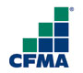

Third Quarter for CFMA was filled with so many wonderful things.

In October, we had a joint meeting with ABC bringing Arniban Basu to Middle TN. He told us all about the current economic climate for Middle Tennessee and around our country.

We also had great weather, food and fun for our annual Mini Putt-Putt outing. Families were able attend and laughter was had by all.

In November, we were able to award five scholarships to deserving Middle Tennessee recipients. We also enjoyed a captivating speaker, Mr. Riddley Wills, as he showed us the history and architecture of our great city.

December brought the holidays and our Christmas Party @ the Frist.

Above all, the construction industry grew during this time frame here in Nashville as well Middle Tennessee. Places like the Omni Hotel opened its doors to the public and many other great new construction projects were started.

If you have any questions, don’t hesitate to contact me.

Andrea Nicholson,

Summit Constructors, Inc.

[anicholson@summitconstructors.com](mailto:anicholson@summitconstructors.com)

[http://midtn.cfma.org](http://midtn.cfma.org/)

Third Quarter 1

CoSponsors Arniban Basu 2

Mini Putt-Putt Tourney 2

Scholarship Dinner 2

Christmas @ the Frist 3

Anniversaries 3

Board of Directors 2013-2014 3

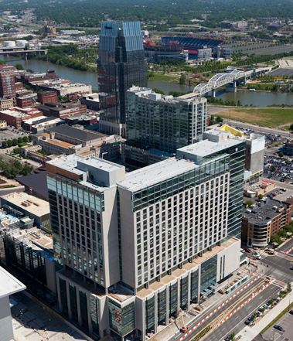

Inside this issue:

October, November, December 2013

**Page 2**

## **Arniban Basu Lunch Meeting with fellow sponsors ABC and Merryman-Farr**

## **October 9, 2013**

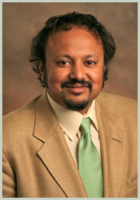

We heard an economic report of Middle Tennessee and our country from Arniban Basu, CEO and Chairman of Sage Policy Group, Inc. out of Baltimore, MD. This was a dynamic presentation by one of the top Economist in our nation. His dry humor and wit helped to soften the blow where our economy is heading. He pointed out that growth is very slow. In bigger cities, like Nashville it will grow at a slower pace than usual. He also pointed out that we are coming into an election year and politicians will not be quick to change any economic policies for the coming year of 2014. He also stated that the recent acceleration in economic activity sets the stage for a much better 2014 for both the broader economy and the nonresidential construction industry. He also stated that materials prices continue to be unusually well behaved, neither rising nor falling aggressively on a month-to-month basis even though those numbers can be swayed with gas prices.



**3rd Annual CFMA Mini Putt-Putt Tourney**

**October 18th, 2013**

Grand Old Golf and Entertainment hosted us again for our Mini Putt-Putt Tourney. A group of about 15 members with family and friends made our annual Mini Putt-Putt Tourney for CFMA. We were able to raise another $300 dollars towards our scholarship fund. We did enjoy a great outing on the patio with food provided by Summit Constructors, Inc. and drinks by KraftCPAs PLLC after an exhausting round of golf.

**CFMA Annual Scholarship Dinner**

**November 19th, 2013**



We were very delighted to have Ridley Wills III be our keynote speaker at one of our favorite events all year, our scholarship dinner. He did a wonderful presentation on architecture here in our great city of Nashville. Our happy hour was sponsored by Robert Harris, with RLH Agency LLC. This year we were able to raise and award five scholarships in the amount of $1,000 to Mirza Jasarevski, Thomas Allen, David Adams, Breanna Thurman and Courtney Tucker. We also gave our membership of the year award to an outstanding member of our organization that has actively participated as the year has progressed. This year it was awarded to Harold Harr, Regional Sales Manager for Comdata.

Page 3

### **Christmas Party @ the Frist**

**December 5, 2013**



**3rd Quarter Anniversaries**

October, November, December 2013

This was our second time doing a dinner and exhibit at the Frist. George Parrott, with Cooper, Travis & Company, PLC, was once again able to sponsor us dinner, musical entertainment, and a wonderful exhibit to walk through. The band had a jazz flair. The exhibit was Norman Rockwell, and the café had great sandwiches and drinks. Even the rain couldn’t stop about 35 of our members and guest from enjoying the fellowship during the Christmas season. I do hope you make plans to come next year.

**October**

Monty Peek 17 years

Phil Minnicks 16 years

Mark Neal 15 years

Sharon Vance 14 years

Patricia Phipps 13 years

Harold Harr 9 years

Boris Jordanov 9 years

Roy Osborne 7 years

Andrea Nicholson 6 years

Clint Brasier 4 years

Dawayne Lusk 4 years

Lea Boucher 4 years

Matthew Brady 2 years

Paul Madigan 1 year

Vicky Hinesley 1 year

Karen Johnston 1 year

**November**

Jason Henley 20 years

Tim Sullivan 11 years

Michelle Casady 9 years

Charles Royse 9 years

Kimberly Anderson 5 years

Ronald Martin 1 year

Heather Whigham 1 year

Matthew Coffey 1 year

Kenneth Moore 1 year

**Board of Directors 2013-2014**

Nicholson, Andrea Summit Constructors, Inc. President

Lee, Alex The Wills Company Vice-President

Moran, John W R Newman & Associates, Inc. Treasurer

Moss, Jerry Kraft CPAs, PLLC Secretary

Carter, Todd Pinnacle Financial Partners Board Member

Colwell, John Crowe Horwath LLP Board Member

Hale, Matthew Cooper, Travis & Company, PLC Board Member

Harr, Harold Comdata Corporation Board Member

Harris, Robert RLH Agency, LLC Board Member

Hurless, Kim Merryman-Farr, LLC Board Member

Kline, Russell Stansell Electric Company, Inc. Board Member

Osborne, Roy Lee Company Board Member

Parrott, George Cooper, Travis & Company, PLC Board Member

Pedigo, James Crain Construction, Inc. Board Member

Rice, Charles HCA Past President 2012-2013

**December**

Jeff Phillips 20 years

Robert Harris 16 years

Donald Morvai 15 years

John Pickard 4 years